**Oracle 11g Release 2 Installation Steps**

1. Download Oracle Database 11g release 2.
2. Run the setup.exe

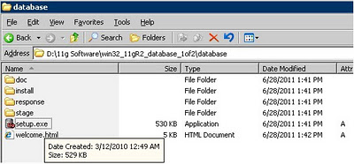

1. Leave empty the email column and MyOracle Support Password field. Then, click Next button.

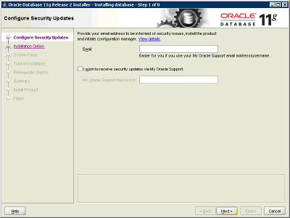

1. Select the first option “Create and configure a database”. Then click Next button.

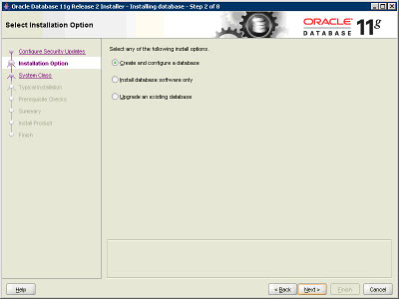

1. Choose “Desktop Class” option. Click Next button.

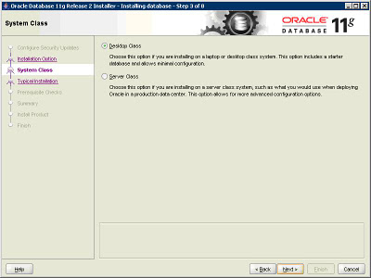

1. In Typical Installation screen use the default location setting which is normally the location will be in C drive. Key in the Administrative Password and confirm password. The password should be minimum 8 characters with one uppercase letter and one lower case letter. Then, click Next button.

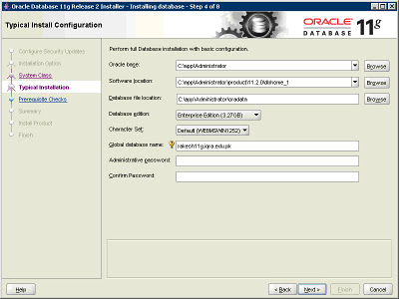

1. Click Finish button.

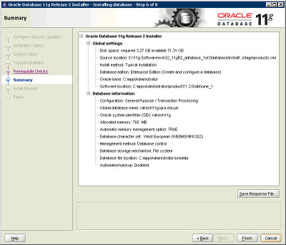

1. The installation will be in progress.

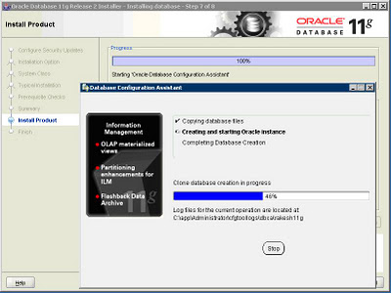

1. Installation of Oracle Database will show successful.

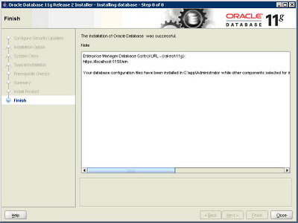

1. Once installation finish, go to Program Files🡪 Oracle-OraDb11g_home1🡪Application Development 🡪 SQL Plus.

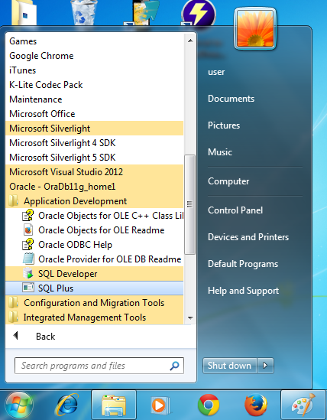

1. The SQL Plus screen will be executed.

